**Install dlib and face-recognition library in Window 10**

Following steps:

1. Your system must have python 3.6.0 version
2. Install cmake library using the command

**$ pip install cmake**

Then set this cmake path to environment variable as shown in figure

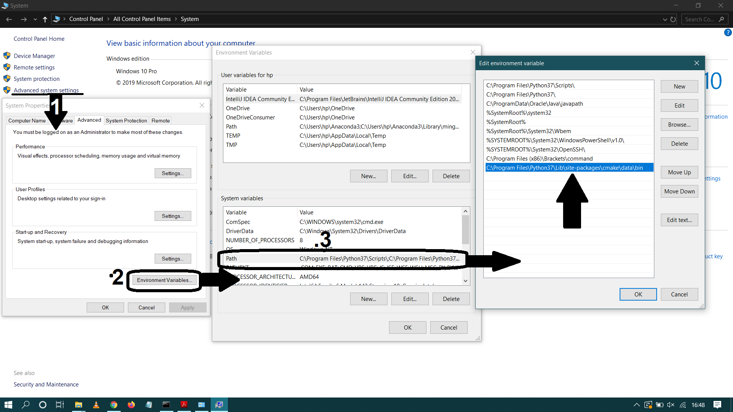

After adding this path check cmake command on command prompt

1. Now install dlib.   
   dlib different version exists but when an attempt to install errors occurs.

The best solution I found I that

When you follow the above instruction completely

Then again open the command prompt and copy this line

$ python -m pip install <https://files.pythonhosted.org/packages/0e/ce/f8a3cff33ac03a8219768f0694c5d703c8e037e6aba2e865f9bae22ed63c/dlib-19.8.1-cp36-cp36m-win_amd64.whl#sha256=794994fa2c54e7776659fddb148363a5556468a6d5d46be8dad311722d54bfcf>

link for this tutorial is: <https://pysource.com/2019/03/20/how-to-install-dlib-for-python-3-on-windows/>

The following result show as

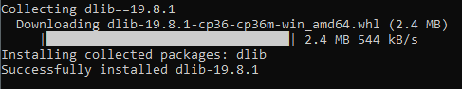

1. Now turn to install face recognition library on window

Run this command on command prompt

**$ pip3 install face_recognition**